Laubach Literacy Ontario
Sample Activities using Authentic Workplace Materials
Integrating Essential Skills into Tutor Training



Acknowledgements:

Research Writer: Robyn Cook-Ritchie
Managed by: Lana Faessler
Independent Evaluator: Stephanie Brennan

Translation: Janie Bertrand

Provincial Partners: Laubach Literacy New Brunswick
Literacy Volunteers of Quebec
AlphaPlus Centre

Employment Partners: Hawco Products Limited
Montreal Woollens (Canada) Ltd.

Field Test Sites: Literacy Unlimited (Quebec)
Midland Area Reading Council (Ontario)
Moncton Regional Learning Council (New Brunswick)
RECLAIM Literacy Council (Quebec)
The Literacy Group of Waterloo Region (Ontario)
Yamaska Literacy Council (Quebec)

Published by: Laubach Literacy Ontario
8A-65 Noecker Street
Waterloo, ON N2J 2R6
T: 519.743.3309
F: 519.743.7520
Website: http://www.laubach-on.ca/

February 2010

Laubach Literacy Ontario gratefully acknowledges funding for this project provided by the Federal Government through Human Resources and Skills Development Canada.

Sample Activities using Authentic Workplace Materials

The booklet contains eight sample activities using authentic workplace materials that were provided by two employment partners through the Integrating Essential Skills into Literacy Tutor Training project. The sample activities were developed to serve as models that can be adapted to meet individual learner needs.

Each sample activity has a cover page with summary information and instruction notes, information related to the relevant occupation from the Essential Skills profiles including sample tasks, and authentic materials from the employer partners. Learners will require prior learning and skill development prior to completing the sample activities. The sample activities focus on Reading Text, Document Use, Numeracy and Writing. Many sample activities include an optional extension activity that involved computer use.

The Essential Skills profiles found in each sample activity come from the Essential Skills Profiles on the Human Resources and Skills Development website (last accessed on July 11, 2009). The same tasks listed in each activity are found in the Essential Skills Profiles. However, for the purposes of this project they were downloaded from the database on the Ontario Skills Passport site: http://skills.edu.gov.on.ca/OSPWeb/jsp/en/login.jsp (last accessed on January 31, 2010).

The Chemical Plant sample activities were developed using authentic materials provided by Hawco Products Limited. The Textile Plant sample activities were developed using authentic materials provided by Montreal Woollens (Canada) Ltd.

Activity List
 | Activity | Essential Skill Focus | Level | Other Essential Skills | Page
Chemical Plant | Using a Product Catalogue | Reading Text  Document Use | 2  2 | Writing | 5
Chemical Plant | Completing a Goods Return Report | Document Use | 2 | Writing | 14
Chemical Plant | Completing a Safety Circle Check | Document Use | 2 | Writing | 19
Chemical Plant | Understanding a Material Safety Data Sheet (MSDS) | Reading Text  Document Use | 3  3 | Writing  Numeracy  Computer Use | 25
Textile Plant | Choosing Personal Protection Equipment (PPE) | Reading Text  Document Use | 2  2 | Computer Use | 31
Textile Plant | Completing a Return Authorization | Document Use  Writing | 2  1 | NA | 37
Textile Plant | Understanding Workplace Policies | Reading Text | 2 | NA | 42
Textile Plant | Calculating Pay | Numeracy | 2 | Reading Text | 52

Essential Skill Focus:
☑ Reading Text
☑ Document Use

Other Essential Skills that may be used:
☑ Writing

Laubach Literacy Ontario– Integrating Essential Skills
Activity: Using a Product Catalogue

In this activity the learner will be:
♦ Finding and using information
♦ Communicating ideas and information

Instructional Focus:
How the learner answers the questions is not as important as the fact that they understand how to use the catalogue to find information and that they understand a little bit about the product that they have been asked to make.

Learning Styles and Learner Readiness:
For all questions, the learner can answer by writing a short answer, writing a short paragraph or they can answer orally. A learner who may not be ready or want to write out the answers to the questions should have the option to answer orally.

Laubach Supplement:
For more information on selecting materials that support a learner working on ES Level 1-2 tasks please refer to the charts on pages 3-8 of Linking Laubach With Essential Skills. This resource can be found in the publications section on the Laubach Literacy Ontario Website: http://www.laubach-on.ca/

Explore and Extend:
The activity is designed so the learner finds out what they need to know to be able to do the job. If a learner has an interest in learning more they can extend the activity. The transfer of knowledge and skills is supported by extending the activities. The explore and extend step often involves other Essential Skills and may require instructor support.
Other Activities Related to these Profiles:
Completing a Goods Return Report
Completing a Safety Circle Check
Understanding and using a Material Safety Data Sheet (MSDS)
Essential Skill Profiles:
Labourers in Chemical Plant Processing and Utilities
NOC Code: 9613

Chemical Plant Machine Operators
NOC Code: 9421

Using a Product Catalogue
Essential Skills Profile Information
Labourers in Chemical Plant Processing and Utilities
NOC Code: 9613
Labourers in this unit group carry out a variety of material handling, cleaning and routine general labouring activities. They are employed by petroleum and natural gas processing, pipeline and petrochemical, chemical and pharmaceutical companies, and by electrical, water and waste treatment utilities.

Sample Level 2 Reading Text and Document Use tasks for this occupation:
Read catalogues for information on new products and processes | Reading Text
Read company procedures | Reading Text
Read instructions for operating equipment | Reading Text
Read memos posted on the bulletin board concerning changes in policies or dates of meetings, such as union meetings | Reading Text
Complete forms such as tally sheets to document information on different products | Document Use
Enter numerical information about processes into operators' reports | Document Use
Read shipping and receiving forms and packing slips | Document Use
Refer to production charts | Document Use
Refer to shift schedules and work orders | Document Use

Chemical Plant Machine Operators
NOC Code: 9421
Chemical plant machine operators monitor and operate units and machinery to blend, mix, process and package a wide range of specialty chemicals, pharmaceuticals, cleaning and toiletry products. They are primarily employed in chemical, cleaning compound, ink and adhesive industries, but may also be employed by chemical processing departments in other industries.

Sample Level 2 Reading Text and Document Use tasks for this occupation:
Read instruction sheets that accompany new products | Reading Text
Read memos from management to stay informed of management priorities | Reading Text
Read standard operating procedures set forth by the company | Reading Text
Read trade publications and magazines to keep informed of the latest products and trends | Reading Text
Complete forms, such as maintenance request forms and production and process forms which are part of the quality assurance program | Document Use
Interpret sanitation logs and enter information in them | Document Use
Read work schedules posted in the plant which show the number of batches of specific products to be completed by certain dates | Document Use

Using a Product Catalogue Activity

Background

It is your first week on the job and you will be making "Husky Degreaser". Before you start, you have been asked to review the catalogue to learn a little more about the products that the company makes.

Most manufacturing companies have a catalogue. A catalogue is a "document" that lists the products a company sells or distributes. The catalogue describes the items that the company sells. Products are usually organized in groups of items that are similar. The table of contents helps you to locate the product you are looking for in the catalogue. Catalogues may also have a legend of symbols that are used in the catalogue. The legend explains what the symbols mean. Each product usually has a written description in a catalogue. The product descriptions explain what each product does.

To complete this activity you will be using the following two pages from a product catalogue from the chemical manufacturing plant. The first page is the table of contents. The second page is where information about Husky Degreaser is found.
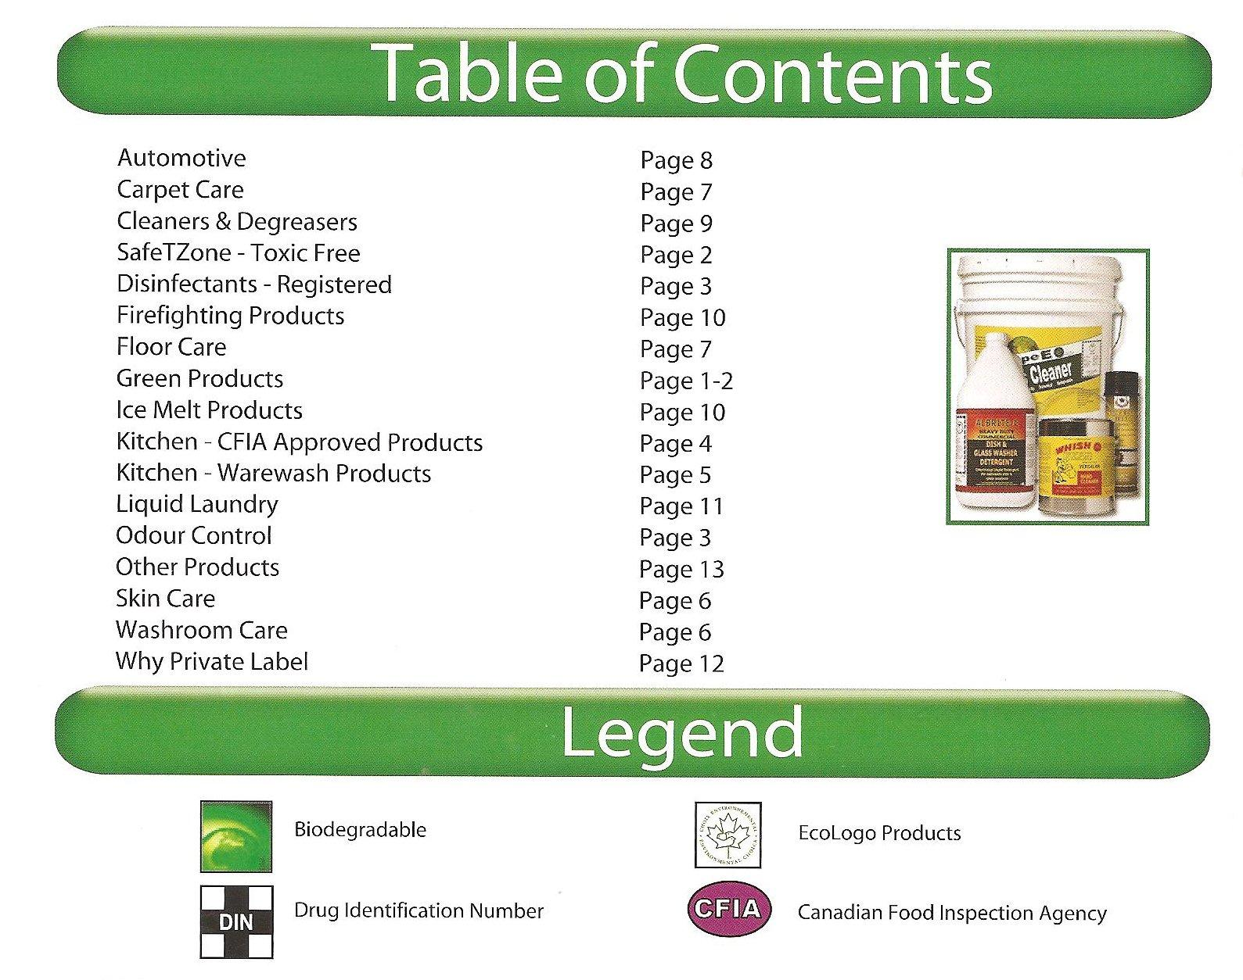

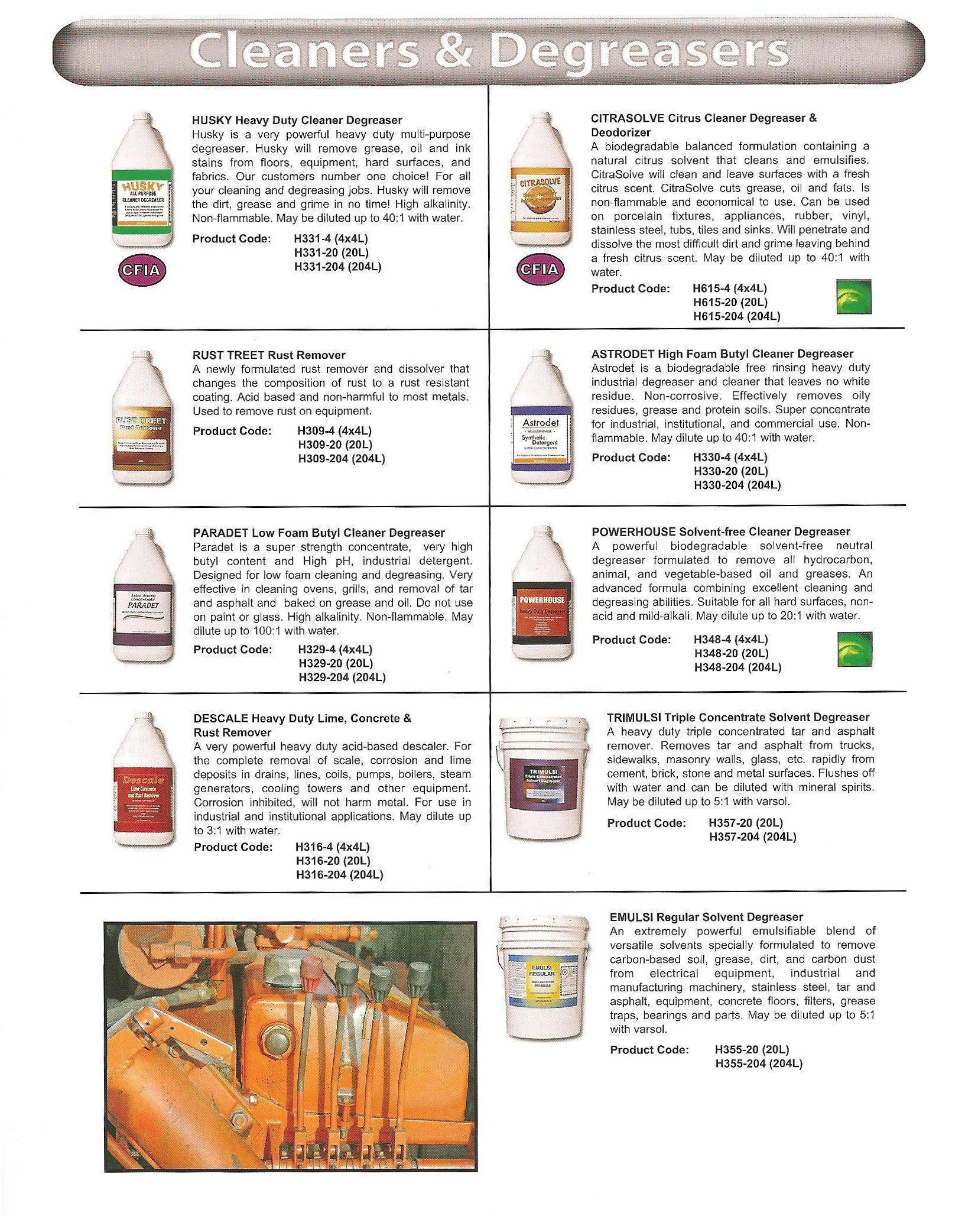

Part A: The Table of Contents

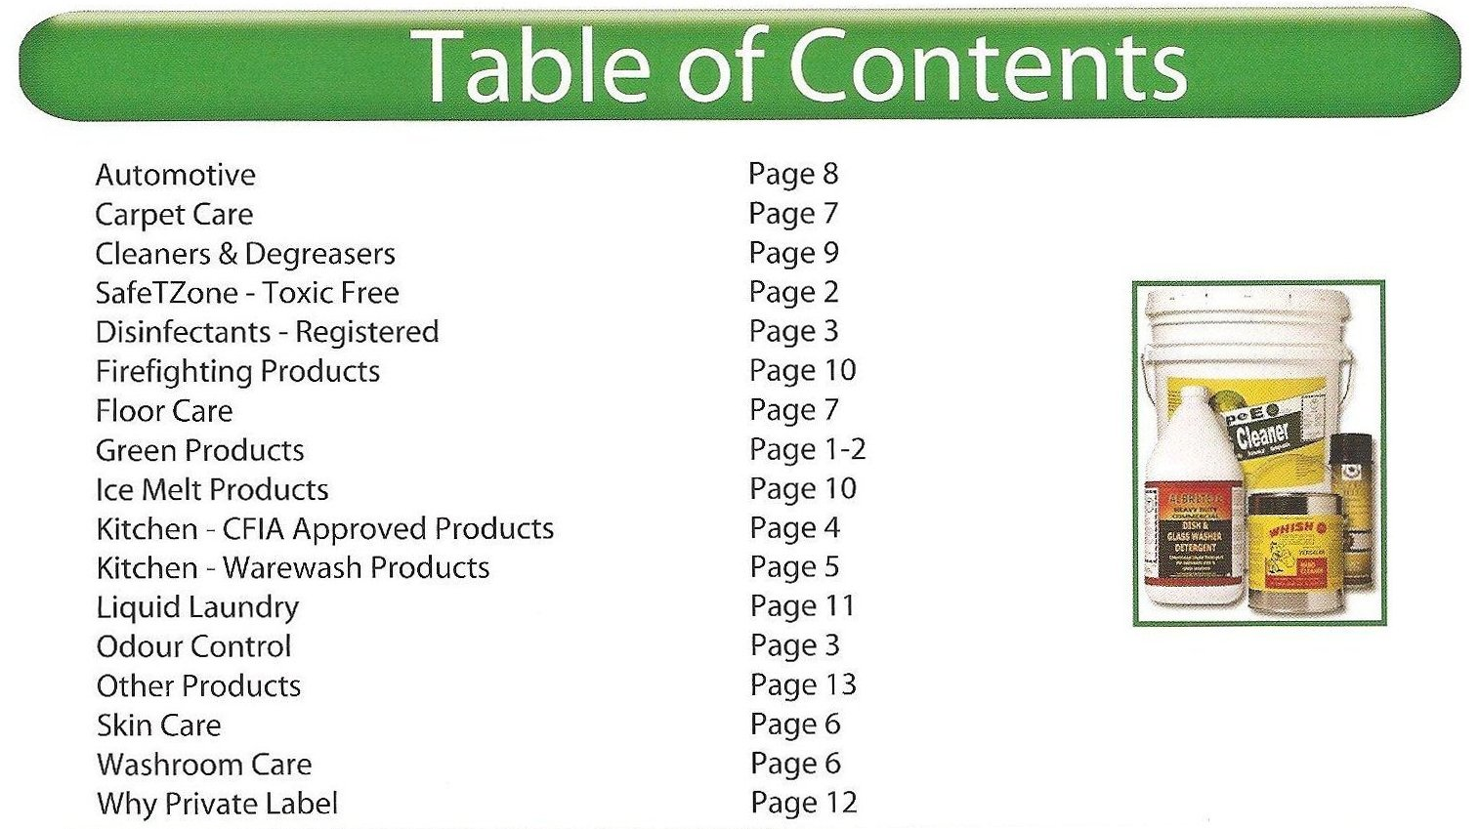

Step 1: Review and Connect
Look at the Table of Contents.

Think about other table of contents that you have seen in the past (e.g. in a book). How is it the same? How is it different?

Step 2: Read for Meaning
Look at the Table of Contents.

What page would you find Husky Degreaser on? How do you know this?

Part B: The Legend

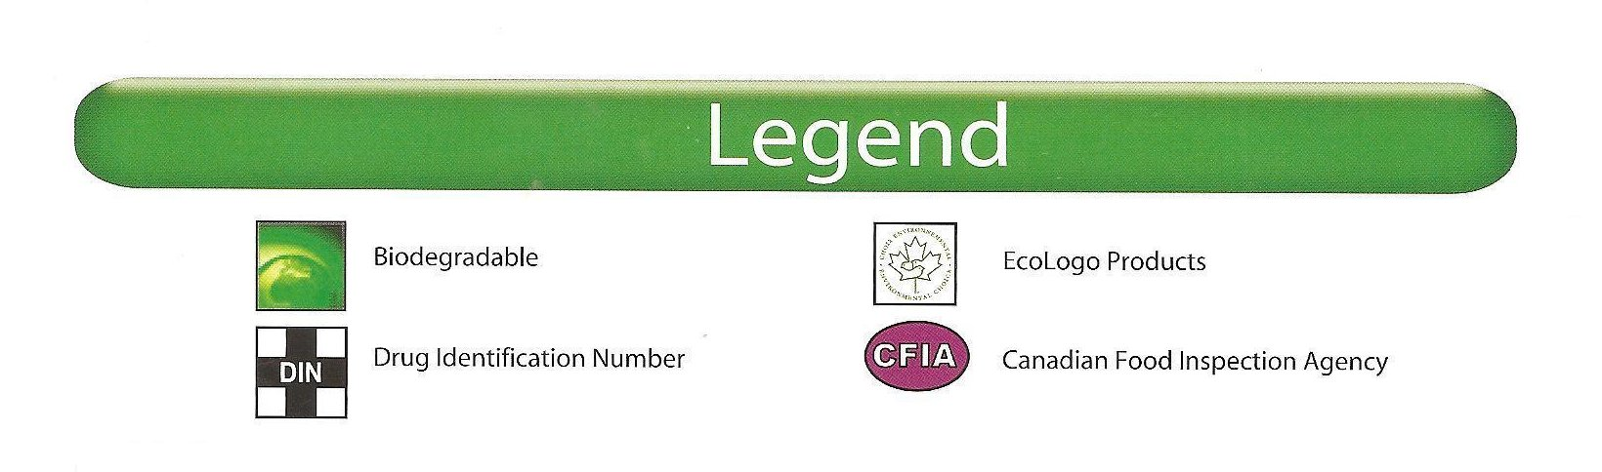

Step 1: Review and Connect
Look at the Legend.

Think about legends that you may have seen in the past (e.g. on a map). How is this legend the same? How is it different?

Step 2: Read for Meaning and Responding
Look at the Legend.

Discuss the meaning of each symbol.

Explore and Extend (optional)
Look at the Legend.

Find out more about the four symbols that are listed. Do an internet search to find out about each symbol.

Part C: The Catalogue Page

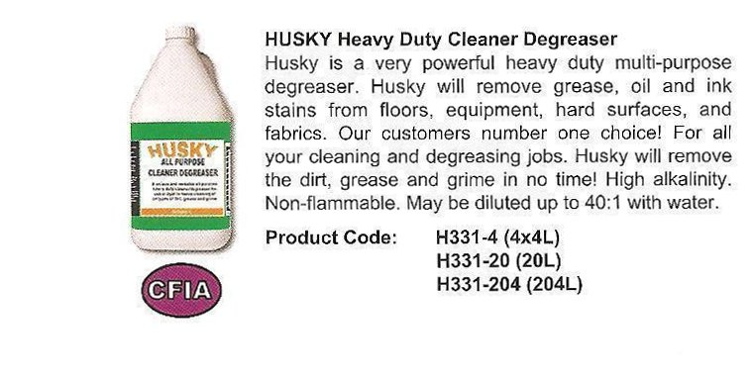

Step 1: Review and Connect
Look at the entry for Husky Degreaser.

Think about catalogue entries you have seen in the past (e.g. department store). How is it the same? How is it different?

Step 2: Read for Meaning and Responding
Look at the entry for Husky Degreaser.

- What does the symbol beside Husky Degreaser stand for?
- What does Husky Degreaser do?
- What is the product code for 4x4 litre bottles of Husky Degreaser?
- What is the ratio of dilution for Husky Degreaser?

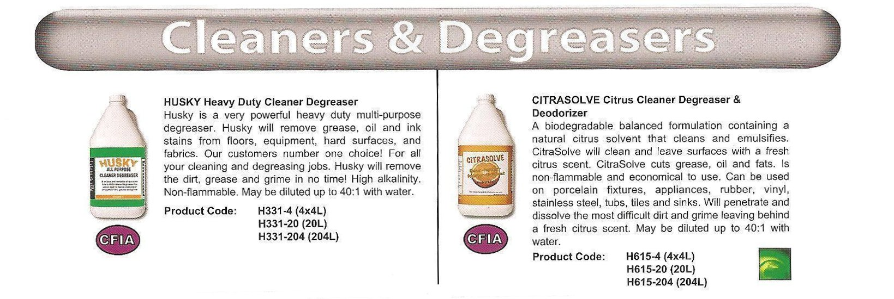

Explore and Extend (optional)
Look at the entries for Husky Degreaser and Citrasolve Degreaser.

Review the entry for Citrasolve Degreaser. Compare it with Husky Degreaser. What are the similarities to Husky Degreaser? What are the differences? Compare in the chart below.

 | Husky Degreaser | Citrasolve Degreaser
Similarities

Differences

Essential Skill Focus:
☑ Document Use

Other Essential Skills that may be used::
☑ Writing

Laubach Literacy Ontario– Integrating Essential Skills
Activity: Completing a Goods Returned Report

In this activity the learner will be:
♦ Finding and using information
♦ Communicating ideas and information

Instructional Focus:
The focus of the activity is for the learner to become comfortable with completing the report.

Learning Styles and Learner Readiness:
For step 1 and step 2, the learner can answer using by writing a short answer, writing a short paragraph or they can answer orally. A learner who may not be ready or want to write out the answers to the questions should have the option to answer orally. The learner must complete the report in writing in step three.

Laubach Supplement:
For more information on selecting materials that support a learner working on ES Level 1-2 tasks please refer to the charts on pages 3-8 of Linking Laubach With Essential Skills. This resource can be found on the Laubach Literacy Ontario Website: http://www.laubach-on.ca/

Explore and Extend:
The activity is designed so the learner finds out what they need to know to be able to do the job. If a learner has an interest in learning more they can extend the activity by practicing completing the report with other return scenarios. The transfer of knowledge and skills is supported by extending the activity.
Other Activities Related to these Profiles:
Using a Product Catalogue
Completing a Safety Circle Check
Understanding and using a Material Safety Data Sheet (MSDS)

Essential Skill Profiles:
Labourers in Chemical Plant Processing and Utilities
NOC Code: 9613

Chemical Plant Machine Operators
NOC Code: 9421

Completing a Goods Returned Report
Essential Skills Profile Information
Labourers in Chemical Plant Processing and Utilities
NOC Code: 9613
Labourers in this unit group carry out a variety of material handling, cleaning and routine general labouring activities. They are employed by petroleum and natural gas processing, pipeline and petrochemical, chemical and pharmaceutical companies, and by electrical, water and waste treatment utilities.

Sample Level 2 Document Use tasks for this occupation:
Complete forms such as tally sheets to document information on different products | Document Use
Enter numerical information about processes into operators' reports | Document Use
Read shipping and receiving forms and packing slips | Document Use
Refer to production charts | Document Use
Refer to shift schedules and work orders | Document Use

Chemical Plant Machine Operators
NOC Code: 9421
Chemical plant machine operators monitor and operate units and machinery to blend, mix, process and package a wide range of specialty chemicals, pharmaceuticals, cleaning and toiletry products. They are primarily employed in chemical, cleaning compound, ink and adhesive industries, but may also be employed by chemical processing departments in other industries.

Sample Level 2 Document Use tasks for this occupation:
Complete forms, such as maintenance request forms and production and process forms which are part of the quality assurance program | Document Use
Interpret sanitation logs and enter information in them | Document Use
Read work schedules posted in the plant which show the number of batches of specific products to be completed by certain dates | Document Use

Completing a Goods Returned Report Activity

Background

You receive a shipment of Husky Degreaser that has been returned by a customer. It is your job to complete the Good Returned Report for the office.

Most manufacturing companies have a process for customers to return products if there is a problem. A Goods Returned Report is a document that you have to complete when a product is returned. In order to complete the report you need to make sure you have all the information you need. For example, you will need to know the date, what is being returned, who returned the product, and why it is being returned.

To complete this activity you will be using the Goods Returned Report found on the next page.
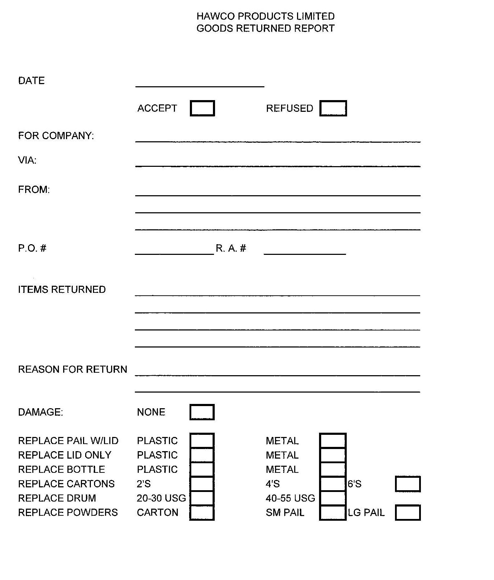

Step 1: Review and Connect
Look at the Goods Returned Report.

Think about other reports that you have seen in the past. For example, when you return an item of clothing to the store the clerk might have filled out a similar report to say why you were returning the item. Can you think of any other examples?

Step 2: Review for Meaning
Look at the Goods Returned Report.

What information do you need to fill out the goods returned report?
Is there any information required on the form that you don’t understand? Discuss this with your instructor.

Step 3: Complete the Report

Complete the Goods Returned Report using the following information:

- The date today is February 3.
- The product being returned is Husky Degreaser.
- One pail of degreaser with a plastic lid is being returned.
- The product being is being returned by Thailand Restaurant.
- The customer wants the pail replaced. The lid on the pail is damaged.
- The product was shipped back to you by Purolator.
- The original purchase order number (P.O. #) was 6070.
- You are accepting the return. The return authorization number (R.A. #) is 55.

Explore and Extend (optional)

Create your own product return scenario and practice filling out the report.

Essential Skill Focus:
☑ Document Use

Other Essential Skills that may be used:
☑ Writing

Laubach Literacy Ontario– Integrating Essential Skills
Activity: Completing a Safety Circle Check

In this activity the learner will be:
♦ Finding and using information
♦ Communicating ideas and information

Instructional Focus:
The focus of the activity is for the learner to understand what a checklist is and become comfortable completing the safety circle check form.

Learning Styles and Learner Readiness:
For step 1 and step 2, the learner can answer by writing a short answer, writing a short paragraph or they can answer orally. A learner who may not be ready or want to write out the answers to the questions should have the option to answer orally. The learner must complete the form in writing in step three.

Laubach Supplement:
For more information on selecting materials that support a learner working on ES Level 1-2 tasks please refer to the charts on pages 3-8 of Linking Laubach With Essential Skills. This resource can be found on the Laubach Literacy Ontario Website: http://www.laubach-on.ca/

Explore and Extend:
The activity is designed so the learner finds out what they need to know to be able to do the job. If a learner has an interest in learning more they can extend the activity by practicing completing the safety circle check with other scenarios. The transfer of knowledge and skills is supported by extending the activity.
Other Activities Related to these Profiles:
Using a Product Catalogue
Completing a Goods Return Report
Understanding and using a Material Safety Data Sheet (MSDS)

Essential Skill Profiles:
Labourers in Chemical Plant Processing and Utilities
NOC Code: 9613

Chemical Plant Machine Operators
NOC Code: 9421

Completing a Safety Circle Check
Essential Skills Profile Information
Labourers in Chemical Plant Processing and Utilities
NOC Code: 9613
Labourers in this unit group carry out a variety of material handling, cleaning and routine general labouring activities. They are employed by petroleum and natural gas processing, pipeline and petrochemical, chemical and pharmaceutical companies, and by electrical, water and waste treatment utilities.

Sample Level 2 Document Use tasks for this occupation:
Complete forms such as tally sheets to document information on different products | Document Use
Enter numerical information about processes into operators' reports | Document Use
Read shipping and receiving forms and packing slips | Document Use
Refer to production charts | Document Use
Refer to shift schedules and work orders | Document Use

Chemical Plant Machine Operators
NOC Code: 9421
Chemical plant machine operators monitor and operate units and machinery to blend, mix, process and package a wide range of specialty chemicals, pharmaceuticals, cleaning and toiletry products. They are primarily employed in chemical, cleaning compound, ink and adhesive industries, but may also be employed by chemical processing departments in other industries.

Sample Level 2 Document Use tasks for this occupation:
Complete forms, such as maintenance request forms and production and process forms which are part of the quality assurance program | Document Use
Interpret sanitation logs and enter information in them | Document Use
Read work schedules posted in the plant which show the number of batches of specific products to be completed by certain dates | Document Use

Completing a Safety Circle Check Activity

Background

You are in charge of running the forklift to move several skids of Husky Degreaser. Before starting you have to complete a Safety Circle Check for the forklift. Safety inspections are required daily by a forklift operator. Once the Safety Circle Check is filled out it needs to be placed in the binder for the forklift. If health and safety officers visit the plant, they will check the binder for the forklift to make sure the Safety Circle Check has been filled out every day. The employer is responsible for reviewing the Safety Circle Check each day and must make sure that any work required is completed.

To complete this activity you will be using the completed Safety Circle Check form and the blank Safety Circle Check form found on the next two pages.

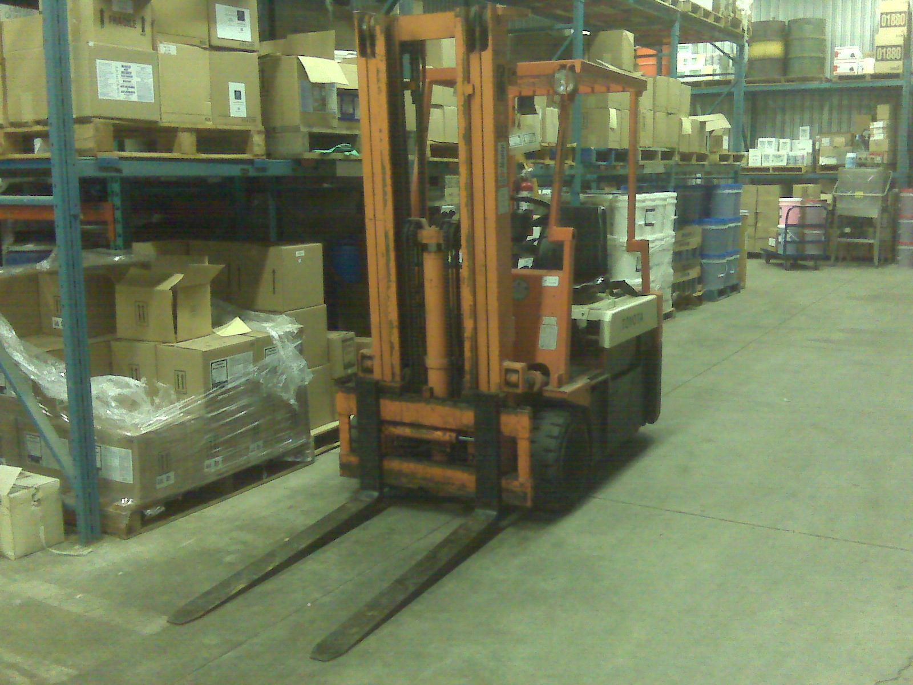

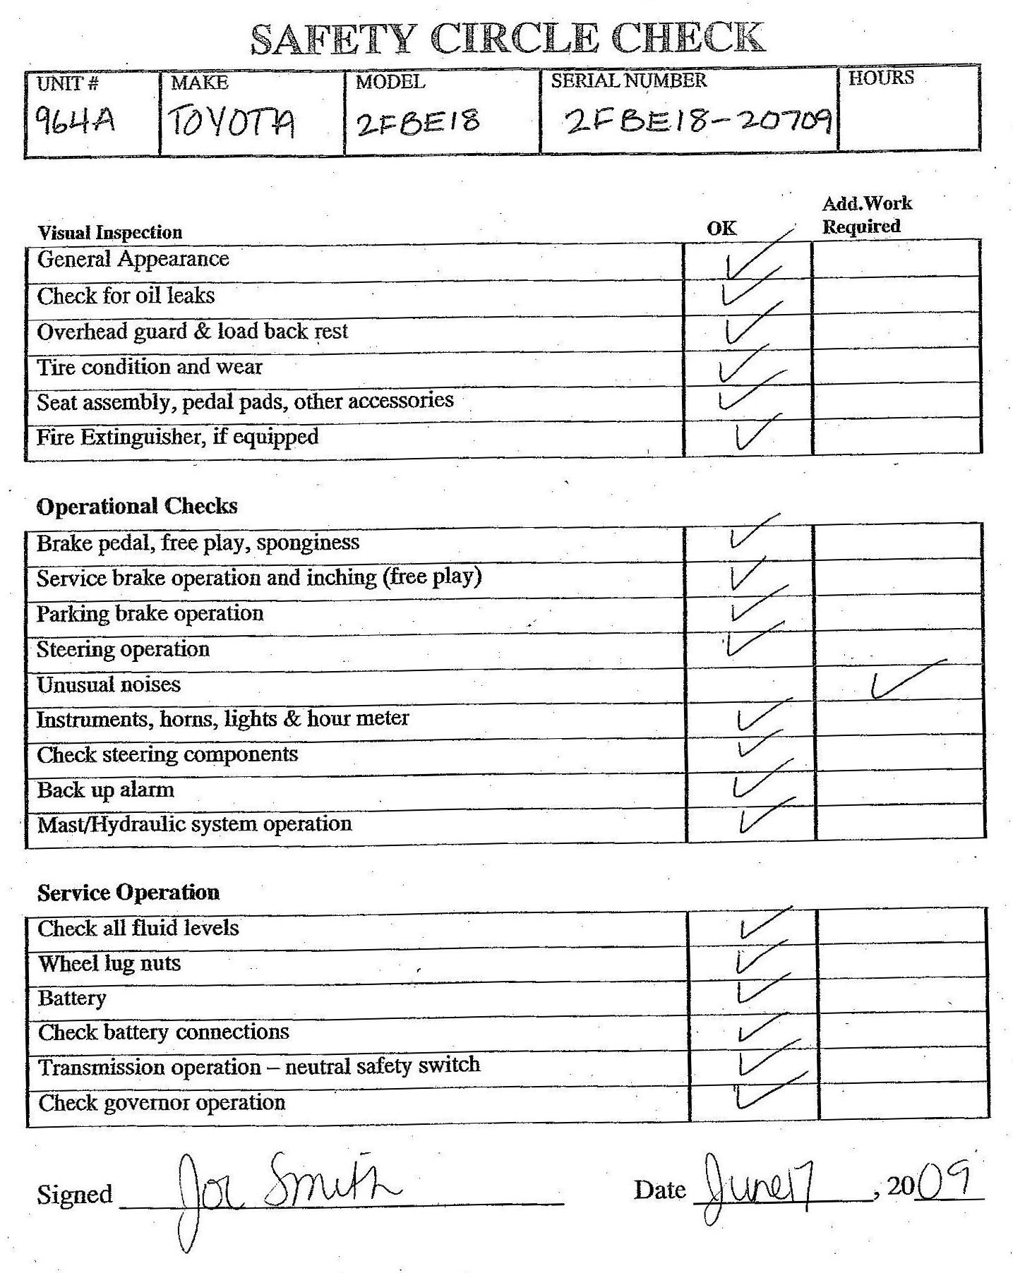

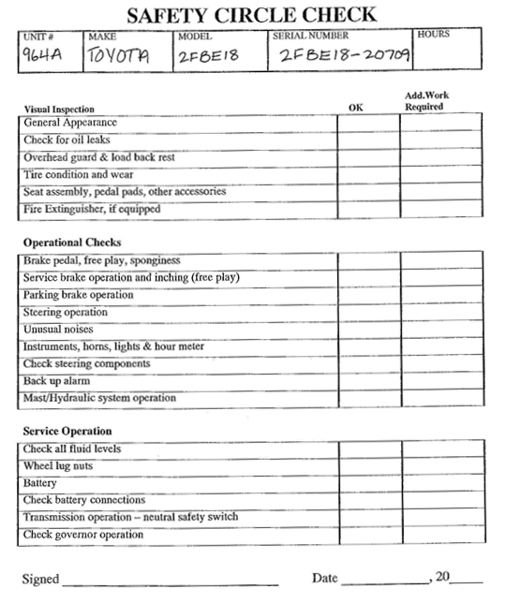

Step 1: Review and Connect
Look at the completed Safety Circle Check.

Think about other check list forms that you have seen in the past. For example, you may have used a check list when shopping. Can you think of any other examples?

Step 2: Review for Meaning
Review the completed Safety Circle Check form.

Are there any problems with the forklift that are indicated on the safety circle check?

Step 3: Complete the Safety Circle Check

What information do you need to fill out the form?
Is there any information on the form that you don’t understand? Discuss this with your instructor.

Complete the Safety Circle Check using the following information:

- The date is February 22, 2009.
- The unit is 965B.
- The forklift is a Toyota 2FRGT20 and the serial number 2FRGT20-20339.
- One of the wheel lug nuts is loose.
- Everything else is okay.

Explore and Extend (optional)

Equipment safety is very important in any workplace. Create your own forklift check information and practice filling out the checklist. Brainstorm what you would do if you discovered that the forklift had the same problem the next time you filled out the safety circle check.

Essential Skill Focus:
☑ Reading Text
☑ Document Use

Other Essential Skills that may be used:
☑ Writing
☑ Numeracy
☑ Computer Use

Laubach Literacy Ontario– Integrating Essential Skills
Activity: Understanding a Material Safety Data Sheet (MSDS)

In this activity the learner will be:
♦ Communicating ideas and information
♦ Finding and Using Information
♦ Using numbers and thinking in quantitative terms

Instructional Focus:
The focus of the activity is for the learner to understand what a material safety data sheet is.

Learning Styles and Learner Readiness:
In this activity the learner can answer by writing a short answer, writing a short paragraph or they can answer orally. A learner who may not be ready or want to write out the answers to the questions should have the option to answer orally.

Laubach Supplement:
For more information on selecting materials that support a learner working on ES Level 3 tasks please refer to the charts on pages 3-8 of Linking Laubach With Essential Skills. This resource can be found on the Laubach Literacy Ontario Website: http://www.laubach-on.ca/

Explore and Extend:
The activity is designed so the learner finds out what they need to know to be able to do the job. If a learner has an interest in learning more they can extend the activity by looking up other MSDSs online and reviewing them. The transfer of knowledge and skills is supported by extending the activity.
Other Activities Related to these Profiles:
Using a Product Catalogue
Completing a Good Return Report
Completing a Safety Circle Check

Essential Skill Profiles:
Labourers in Chemical Plant Processing and Utilities
NOC Code: 9613

Chemical Plant Machine Operators
NOC Code: 9421

Understanding a Material Safety Data Sheet (MSDS)
Essential Skills Profile Information
Labourers in Chemical Plant Processing and Utilities
NOC Code: 9613
Labourers in this unit group carry out a variety of material handling, cleaning and routine general labouring activities. They are employed by petroleum and natural gas processing, pipeline and petrochemical, chemical and pharmaceutical companies, and by electrical, water and waste treatment utilities.

Sample Level 3 Reading Text and Document Use tasks for this occupation:
Refer to manuals such as the forklift manual or the dangerous goods manual | Reading Text
Interpret scale drawings such as blueprints of gas lines or pipe systems | Document Use
Read assembly drawings for machines, such as moulding machines | Document Use

Chemical Plant Machine Operators
NOC Code: 9421
Chemical plant machine operators monitor and operate units and machinery to blend, mix, process and package a wide range of specialty chemicals, pharmaceuticals, cleaning and toiletry products. They are primarily employed in chemical, cleaning compound, ink and adhesive industries, but may also be employed by chemical processing departments in other industries.

Sample Level 3 Reading Text and Document Use tasks for this occupation:

Read Workplace Hazardous Materials Information System (WHMIS) materials, including Material Safety Data Sheets (MSDS), to understand the chemical properties of the raw materials that are being used | Reading Text
Read updates to statistical process control (SPC) manuals when processes are changed | Reading Text
Read graphs, such as graphs which illustrate waste water usage which are read to identify trends in patterns of use which may indicate a problem | Document Use
Read tables, such as troubleshooting tables which are used when there are problems with product viscosity. The tables give differing catalyst to product ratios and the resulting viscosity | Document Use
Refer to schematic drawings, such as those which show modifications to piping going to the kettle reactor | Document Use

Understanding a Material Safety Data Sheet (MSDS) Activity

Background

It is your first week on the job and you will be making "Husky Degreaser". Before you start, you have been asked to review Material Safety Data Sheet so that you understand more about the product.
A Material Safety Data Sheet (MSDS) is a written document that gives information needed for handling and working with chemicals. They generally contain information about the physical and chemical properties of the product. They also describe potential hazards and tell you what emergency actions should be taken. An MSDS will usually tell you the name of the manufacturer, the MSDS date, and emergency phone numbers.
MSDSs can be found for most substances, including common household products such as cleaners, gasoline, pesticides, certain foods, drugs, and office and school supplies. Familiarity with MSDSs allows for precautions to be taken for potentially dangerous products; seemingly safe products may be found to contain unforeseen hazards.
Employers are required to maintain MSDSs for their workers.
To complete this activity you will be using the MSDS sheet for Husky Degreaser found on the following two pages.

SECTION I - PRODUCT IDENTIFICATION AND PREPARATION INFORMATION

Product Name: HUSKY DEGREASER Chemical Formula: H331
ALKALINE CLEANER
Manufacturer: ABC Distributor: XYZ

Emergency Telephone Number: 1-555-555-5555 Date prepared: May 2, 2009
Hazard Rating
HEALTH: 2 FLAMMABILITY: 0
REACTIVITY: 0 PERSONAL PROTECTION: C

SECTION II - INGREDIENTS (disclosed as per 29 CFR 1910.1200)

Ingredients CAS# Wt% ACGIH-TLV

SURFACTANT BLEND NAV 3 - 7 NONE
SODIUM HYDROXIDE 1310-73-2 1 - 5 2mg/m3
ETHYLENE GLYCOL 111-76-2 5 - 10 25ppm
MONOBUTYL-ETHER
DODECYLBENZENE 27176-87-0 10-30 NONE
SULFONIC ACID
POTASSIUM HYDROXIDE 1310-58-3 5-10 2mg/m3
SODIUM TRIPOLYPHOSPHATE 7758-29-4 1-5 NONE
SODIUM XYLENE 1300-72-7 5-10 NONE
SULFONATE
SECTION III - PHYSICAL DATA

Boiling Point (deg C): 100-105 Specific gravity: 1.07
Composite Partial Vapour Pressure (mm Hg @ 25C): 760 Solubility in Water: (20) INFINITE
pH (as supplied): 13.2 - 13.8 Color: CLEAR GREEN
Physical State: LIQUID Odor: BUTYL ODOR
SECTION IV - FIRE AND EXPLOSION DATA

Flammability: NOT FLAMMABLE
Flash Point (deg C, TCC): NAP LEL: NAP UEL: NAP
Hazardous combustion products: NAP Extinguishing Media: NAP
Special Fire Hazards: NAP
SECTION V - REACTIVITY DATA

Conditions for Chemical Instability: STABLE Incompatible Materials: NONE
Hazardous decomposition products: NIL

Chemical Formula: H331

SECTION VI - TOXICOLOGICAL PROPERTIES

Route of Entry: SKIN CONTACT, EYE CONTACT, INGESTION
EFFECTS OF ACUTE EXPOSURE:
Eye: IRRITATION
Skin: IRRITATION
Ingestion: IRRITATION OF DIGESTIVE TRACT
EFFECTS OF CHRONIC EXPOSURE:
Eyes: IRRITATION TO EYES AND MUCOUS MEMBRANES
Skin: IRRITATION
Carcinogenicity: NAV

SECTION VII- PREVENTATIVE MEASURES

Protective gloves: PVC OR RUBBER
Eye protection: SAFETY GLASSES
Respiratory protection: NOT REQUIRED
Other protective equipment: EYE WASH STATION
Engineering controls: NORMAL VENTILATION
Leak and Spill Procedure: FLUSH SPILL AREA WITH WATER. LARGE: DIKE AND ABSORB WITH INERT ABSORBENT.
Waste disposal: DISPOSE IN ACCORDANCE WITH LOCAL, PROVINCIAL AND FEDERAL REGULATIONS.
Storage Requirements: DRY STORAGE RECOMMENDED. AVOID FREEZING.

SECTION VIII - FIRST AID

Eye contact: Flush with water for 15 minutes and seek medical attention immediately.
Skin contact: Flush with water.
Inhalation: Remove to fresh air.
Ingestion: Drink copious amounts of water or mild vinegar solution. Seek medical attention immediately.
SECTION IX - PREPARATION DATA OF MATERIAL SAFETY DATA SHEET

Additional information/comments:
Prepared By: HAW
NAP - Not Applicable, NAV - Not Available.

Disclaimer
Information for this material safety data sheet was obtained from sources considered technically accurate and reliable. While every effort has been made to ensure full disclosure of product hazards, in some cases data is not available and is so stated. Since conditions of actual product use are beyond control of the supplier, it is assumed that users of this material have been fully trained. No warranty, expressed or implied, is made and supplier will not be liable for any losses, injuries or consequential damages, which may result from the use of or reliance on any information, contained in this form.

Step 1: Review and Connect
Review the Material Safety Data Sheet.

Review how the material safety data sheet is organized. What are the nine main sections? Are there any section headers that you don’t understand? Discuss with your instructor. Can you think of another document you have seen or used that is organized in a similar way?

Step 2: Read for Meaning
Read the Material Safety Data Sheet.

Answer the following questions using the Material Safety Data Sheet.
- Who is the manufacturer?
- What number would you call if there was an emergency?
- What should you do if some of the degreaser got on your skin?
- Is the degreaser flammable?
- What should you do if you accidentally swallow the degreaser?
- What equipment do you need to wear when you are working with the degreaser?

Explore and Extend (optional)

- Search for material safety data sheets online for common household products. Compare different material safety data sheets to the one given in this activity. How are they the same? Are there any differences? For example, do they have the same sections? Compare in the chart below:

 | Husky Degreaser MSDS | Other MSDS
Similarities

Differences

- Search for “MSDS hazard ratings” online. What are the most common symbols used? What does each rating mean?

Essential Skill Focus:
☑ Reading Text
☑ Document Use

Other Essential Skills that may be used:
☑ Computer Use
Laubach Literacy Ontario– Integrating Essential Skills
Activity: Choosing Personal Protection Equipment (PPE)

In this activity the learner will be:
♦ Finding and using information
♦ Communicating ideas and information

Instructional Focus:
How the learner answers the questions is not as important as the fact that they understand the importance of using personal protection equipment. The learner should be able to make the best choice of equipment using the information provided in the policy.
Learning Styles and Learner Readiness:
For all questions, the learner can answer by writing a short answer, writing a short paragraph or they can answer orally. A learner who may not be ready or want to write out the answers to the questions should have the option to answer orally.

Laubach Supplement:
For more information on selecting materials that support a learner working on ES Level 1-2 tasks please refer to the charts on pages 3-8 of Linking Laubach With Essential Skills. This resource can be found in the publications section on the Laubach Literacy Ontario Website: http://www.laubach-on.ca/

Explore and Extend:
The activity is designed so the learner finds out what they need to know to be able to do the job. If a learner has an interest in learning more they can extend the activity. The transfer of knowledge and skills is supported by extending the activities. The explore and extend step often involves other Essential Skills and may require instructor support.
Other Activities Related to these Profiles:
Calculating Pay
Completing a Return Authorization
Understanding Workplace Policies

Essential Skill Profiles:
Labourers in Textile Processing
NOC Code: 9616

Textile Fibre and Yarn Preparation Machine Operators
NOC Code: 9441

Choosing Personal Protection Equipment (PPE)
Essential Skills Profile Information
Labourers in Textile Processing
NOC Code: 9616
Labourers in textile processing perform a variety of manual duties to assist in processing fibres into yarn or thread, or to assist in weaving, knitting, bleaching, dyeing or finishing textile fabrics or other textile products. They are employed by textile companies.

Sample Level 2 Reading Text and Document Use tasks for this occupation:

Read catalogues for information on new products and processes | Reading Text
Read company procedures | Reading Text
Read instructions for operating equipment | Reading Text
Read memos posted on the bulletin board concerning changes in policies or dates of meetings, such as union meetings | Reading Text
Complete forms such as tally sheets to document information on different products | Document Use
Enter numerical information about processes into operators' reports | Document Use
Read shipping and receiving forms and packing slips | Document Use
Refer to production charts | Document Use
Refer to shift schedules and work orders | Document Use

Textile Fibre and Yarn Preparation Machine Operators
NOC Code: 9441
Textile fibre and yarn preparation machine operators operate machines to prepare textile fibres or to spin, wind or twist yarn or thread. They are employed by textile companies.

Sample Level 2 Reading Text and Document Use tasks for this occupation:

Read equipment calibration instructions | Reading Text
Read notes and memos from supervisors concerning production that are posted on the bulletin board | Reading Text
Read product specifications for various types of materials | Reading Text
Read special operating instructions and production procedures | Reading Text
Complete production information forms | Document Use
Read production schedules to determine what type of bobbin to use, what type of thread or strand to use, what procedure to use and what quantity to produce | Document Use
Record production information on a form. This includes identifying the product being run, the time the run began and ended, the batch number, the number of machines in operation and downtime | Document Use
Refer to electronic readings on machines | Document Use
Refer to pictures on packaging instructions as a guide for packing rolls of yarn | Document Use

Choosing Personal Protection Equipment (PPE) Activity

Background

It is you first day on the job at the textile plant. You have been told that the plant is very noisy and that you are required to wear Personal Protection Equipment (PPE) to prevent hearing loss. You need to choose the type of PPE that you would like to wear. You supervisor has provided you with the Hearing Conservation Program policy to review. The policy outlines the different types of PPE that are available.

The decibel (dB) is used to measure sound level. Noise is usually ranked using the A-weighting system (dBA). Loudness is measured in dBA. The louder the noise, the more hazardous it is. Also, the longer the exposure time, the more hazardous the noise is. In the chart below there are examples of common sounds you would hear and the approximate dBA.

Weakest sound heard | 0dBA
Whispering in a Library | 30dBA
Normal conversation | 60-70dBA
Alarm clock | 80dBA
City Traffic (inside car) | 85dBA
Train whistle | 90dBA
Subway train | 95dBA
Motorcycle | 100dBA
Loud Rock Concert | 115dBA
Jackhammer | 103dBA
Loudest sound possible | 194dBA

It is the responsibility of the employer to protect the employee from injury such as hearing loss.

To complete this activity you will be using the Hearing Conservation Program policy on the next two pages.
Update
We have updated our Hearing Conservation Program based on new legislation that lowered the acceptable dBA from 90 to 85. The 85dBA bring us in line with the rest of the provinces in Canada!
A new Hearing Protection Chart has been posted on both Health & Safety Boards (copy attached to this document). This chart outlines the areas of the plant where hearing protection is required. It will be updated as required.
A Hearing Conservation Program is very important—in particular, using the appropriate hearing protection!
The effects of hearing loss can include:
- Anxiety
- Depression
- Fatigue
- Withdrawal from social activities
- Poor digestion
- Stress
- Poor self-image
- Higher blood pressure and heart rate (hypertension)
- Higher cholesterol levels

If you are required to wear hearing protection, a selection of devices will be offered to you. If you choose a non-disposable type of PPE, keep in mind that these devices must be cleaned properly in order to reduce the risk of infection.
NRR = Noise Reduction Rating
 | EAR TaperFit  NRR32  Disposable | Available | Hearing protection must not be modified. If your protection does not fit properly, we may have to look at alternate sizing.
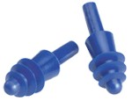 | AirSoft Corded/Un-Corded  NRR27  Reusable | Available
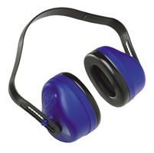 | Assorted Ear Muffs  Minimum NRR20  Reusable | Can be brought in
If there is a style of hearing protection that you prefer, and you don’t see it here, let us know
CARE
EAR TaperFit
- Do not reuse
- Dispose after use
AirSoft Corded/Un-Corded
- Check regularly for wear and tear
- Replace if plugs are no longer pliable
- Wash regularly using a soft brush, warm water and mild detergent (rinse well)
- Squeeze out excess water and place on clean surface to air dry
Assorted Ear Muffs
- Check regularly for wear and tear
- Replace if cushions are no longer pliable or head band has been stretched and a snug fit cannot be achieved
- Wash regularly using a soft brush, warm water and mild detergent (rinse well)
- Ensure material inside the cushion does not become wet
- Squeeze out excess water and place on clean surface to air dry

USE
EAR TaperFit
- Ensure hands are clean
- Roll with thumb and forefinger
- Reach over head with right hand and pull back on left ear
- Using left hand, insert plug into left ear snugly
- Repeat to other side
AirSoft Corded/Un-Corded
- Ensure hands are clean
- Reach over head with right hand and pull back on left ear
- Using left hand, insert plug into left ear snugly
- Repeat to other side
Assorted Ear Muffs
- Ensure cushions create a seal around ears
- Ensure head band rests snugly

If, at any time, you would like extra training on the proper fit, use and care of your PPE, alert your department manager and they will schedule a one-on-one meeting between you and the Human Resources Manager.
I understand the policy regarding our Hearing Conservation Program and will comply with it.
Employee Signature |  | Date |  | HRM Signature

Step 1: Review and Connect
Review the Hearing Conservation Program Policy.

Think about other policies that you have seen in the past. For example, have you seen similar policies in another workplace? Look at the chart in the policy that compares the three types of hearing protection devices that are available. Can you think of other charts like this that you have seen? For example, when you are comparing products on the internet, you might be given the option to compare the products side by side. Can you think of any other specific examples?

Step 2: Read for Meaning
Read the Hearing Conservation Program Policy.

Answer the following questions using the policy.
- What are three potential effects of hearing loss?
- What is the acceptable dBA at the company?
- Which devices are reusable?
- How do you clean reusable devices?
- Which devices are available from the company?

Step 3: Choose your Equipment

Which hearing protection device would you chose to wear? Why would you choose this device?

Sign and date the policy.

Explore and Extend (optional)
You have decided that you want to use the “Ear Muff” hearing protection device. Search online to find an appropriate model and determine how much it will cost.

Essential Skill Focus:
☑ Document Use
☑ Writing

Laubach Literacy Ontario– Integrating Essential Skills
Activity: Completing a Return Authorization

In this activity the learner will be:
♦ Finding and using information
♦ Communicating ideas and information

Instructional Focus:
The focus of the activity is for the learner to become comfortable with completing the form and writing a short note to a supervisor.

Learning Styles and Learner Readiness:
For step 1 and step 2, the learner can answer by writing a short answer, writing a short paragraph or they can answer orally. A learner who may not be ready or want to write out the answers to the questions should have the option to answer orally. The learner must complete step three and step four in writing.

Laubach Supplement:
For more information on selecting materials that support a learner working on ES Level 1-2 tasks please refer to the charts on pages 3-8 of Linking Laubach With Essential Skills. This resource can be found on the Laubach Literacy Ontario Website: http://www.laubach-on.ca/

Explore and Extend:
The activity is designed so the learner finds out what they need to know to be able to do the job. If a learner has an interest in learning more they can extend the activity by practicing completing the form with other return scenarios. The transfer of knowledge and skills is supported by extending the activity.
Other Activities Related to these Profiles:
Choosing Personal Protection Equipment (PPE)
Calculating Pay
Understanding Workplace Policies

Essential Skill Profiles:
Labourers in Textile Processing
NOC Code: 9616

Textile Fibre and Yarn Preparation Machine Operators
NOC Code: 9441

Completing a Return Authorization
Essential Skills Profile Information
Labourers in Textile Processing
NOC Code: 9616
Labourers in textile processing perform a variety of manual duties to assist in processing fibres into yarn or thread, or to assist in weaving, knitting, bleaching, dyeing or finishing textile fabrics or other textile products. They are employed by textile companies.

Sample Level 2 Document Use tasks for this occupation:
Complete forms such as tally sheets to document information on different products | Document Use
Enter numerical information about processes into operators' reports | Document Use
Read shipping and receiving forms and packing slips | Document Use
Refer to production charts | Document Use
Refer to shift schedules and work orders | Document Use

Sample Level 1 Writing tasks for this occupation:
Complete work orders and invoices | Writing
Make log book entries to record tasks completed | Writing
Write changes on worksheets, such as recording the substitution of materials | Writing
Write notes to co-workers to document problems, such as a machine breakdown and write notes to mechanics describing the circumstances of the breakdown | Writing

Textile Fibre and Yarn Preparation Machine Operators
NOC Code: 9441
Textile fibre and yarn preparation machine operators operate machines to prepare textile fibres or to spin, wind or twist yarn or thread. They are employed by textile companies.

Sample Level 2 Document Use tasks for this occupation:
Complete production information forms | Document Use
Read production schedules to determine what type of bobbin to use what type of thread or strand to use what procedure to use and what quantity to produce | Document Use
Record production information on a form. This includes identifying the product being run, the time the run began and ended, the batch number, the number of machines in operation and downtime | Document Use
Refer to electronic readings on machines | Document Use
Refer to pictures on packaging instructions as a guide for packing rolls of yarn | Document Use

Sample Level 1 Writing tasks for this occupation:
Complete forms or e-mail messages to provide production information | Writing
Write notes on stickers to make technicians aware of problems with machines | Writing
Write production details in a log notebook | Writing

Completing a Return Authorization

Background

You have been told by your supervisor to complete a return authorization for a roll of fabric that is defective. It is your job to complete the Return Authorization for the office.

Most manufacturing companies have a process for customers to return products if there is a problem. A Return Authorization is a document that you have to complete when a product is going to be returned. The customer needs the authorization before they can send the product back. In order to complete the form you need to make sure you have all the information you need. For example, you will need to know the return authorization number, the date, what is being returned, who returned the product, and why it is being returned.

To complete this activity you will be using the Return Authorization on the next page.

Step 1: Review and Connect
Look at the Return Authorization.

Think about other forms like this that you have seen in the past. For example, when you return an item of clothing to the store the clerk might have filled out a similar report to say why you were returning the item. Can you think of any other examples?

Step 2: Review for Meaning
Look at the Return Authorization.

What information do you need to fill out the return authorization?
Is there any information required on the form that you don’t understand? Discuss this with your instructor.

Step 3: Complete the Return Authorization

Complete the Return Authorization using the following information:

- You are authorizing the return from Blinds to Go. The office has provided you with the R.A. # 365.
- The date today is June 3.
- The product being returned is a 50 meter roll of fabric. The code for the fabric is LN300RS/0889.
- The piece number is 43375-02-003.
- Franklin Transport will pick up the fabric from Blinds to Go.
- The fabric is being returned because it is the wrong colour.

Step 4: Write a Note to Your Supervisor

When you were on the phone with the Blinds to Go representative they gave you some more information about the return. After you have completed the Return Authorization please write a note to your supervisor letting her know the following:

Three rolls of fabric were shipped at the same time but the roll that they are sending back did not match the other two. Blinds to Go need the roll replaced immediately. They have included a sample from one of the other rolls so that the colour can be matched. Make sure you include the date on the note and attach a copy of the Return Authorization.

Explore and Extend (optional)

Create your own product return scenario and practice filling out the report.
Essential Skill Focus:
☑ Reading Text

Laubach Literacy Ontario– Integrating Essential Skills
Activity: Understanding Workplace Policies

In this activity the learner will be:
♦ Finding and using information
♦ Communicating ideas and information

Instructional Focus:
How the learner answers the questions is not as important as the fact that they understand the importance of the policies and what the policies mean.

Learning Styles and Learner Readiness:
For all questions, the learner can answer by writing a short answer, writing a short paragraph or they can answer orally. A learner who may not be ready or want to write out the answers to the questions should have the option to answer orally.

Laubach Supplement:
For more information on selecting materials that support a learner working on ES Level 1-2 tasks please refer to the charts on pages 3-8 of Linking Laubach With Essential Skills. This resource can be found in the publications section on the Laubach Literacy Ontario Website: http://www.laubach-on.ca/

Explore and Extend:
The activity is designed so the learner finds out what they need to know to be able to do the job. If a learner has an interest in learning more they can extend the activity. The transfer of knowledge and skills is supported by extending the activities. The explore and extend and explore step often involves other Essential Skills and may require instructor support.
Other Activities Related to these Profiles:
Choosing Personal Protection Equipment (PPE)
Calculating Pay
Completing a Return Authorization
Essential Skill Profiles:
Labourers in Textile Processing
NOC Code: 9616

Textile Fibre and Yarn Preparation Machine Operators
NOC Code: 9441

Understanding Workplace Policies
Essential Skills Profile Information
Labourers in Textile Processing
NOC Code: 9616
Labourers in textile processing perform a variety of manual duties to assist in processing fibres into yarn or thread, or to assist in weaving, knitting, bleaching, dyeing or finishing textile fabrics or other textile products. They are employed by textile companies.

Sample Level 2 Reading Text tasks for this occupation:
Read catalogues for information on new products and processes | Reading Text
Read company procedures | Reading Text
Read instructions for operating equipment | Reading Text
Read memos posted on the bulletin board concerning changes in policies or dates of meetings, such as union meetings | Reading Text

Textile Fibre and Yarn Preparation Machine Operators
NOC Code: 9441
Textile fibre and yarn preparation machine operators operate machines to prepare textile fibres or to spin, wind or twist yarn or thread. They are employed by textile companies.

Sample Level 2 Reading Text tasks for this occupation:
Read equipment calibration instructions | Reading Text
Read notes and memos from supervisors concerning production that are posted on the bulletin board | Reading Text
Read product specifications for various types of materials | Reading Text
Read special operating instructions and production procedures | Reading Text

Understanding Workplace Policies

Background

It is your first week on the job at the textile plant. You have been asked to review the Employee Handbook. The Employee Handbook contains all of the workplace policies and procedures. The first policy in the handbook is the Health and Safety Policy. The second policy is the Roles and Responsibilities Policy and Procedure.

A workplace policy is a formal policy which is put in place by the owners of a business. Policies are usually written up and put in a manual or employee handbook. New policies may also be posted on an employee notice board. Employees may be required to provide a signature saying that they have read the policy and they understand it. Having policies in place is important because they protect both employees and employers.

Many topics can be covered by a policy. Things like rate of pay, discrimination and workplace dress code are often addressed in policies. Some policies are put in place because of an external requirement like a government regulation. A well written policy clearly explains the viewpoint of the business on a particular issue, and it will tell you what the consequences are for violating the policy.

In manufacturing plants health and safety for all employees and visitors is very important.

To complete this activity you will be using the Health and Safety Policy and the Roles and Responsibilities Policy and Procedure found on the next six pages.

Policy Title: Health & Safety Policy | Policy Number: PP001
Prepared By: MA | Approved By: JOHSC
Date of Approval: February 25, 2008 | Supersedes: March 20, 2007
Location: All | Date of Review: February, 2009

PURPOSE
The management of MW Canada is vitally interested in the safety of its employees.
The company is committed to providing and maintaining a safe work environment in compliance with industry standards and legislative requirements (at minimum), in order to protect staff, equipment and property.
SCOPE
This policy applies to all MW Canada employees, visitors, contractors and sub-contractors.
ROLES & RESPONSIBILITIES
All employees, visitors, contractors and subcontractors are responsible for minimizing accidents within our facility by complying with safe work practices, policies and procedures. In addition, it is imperative that all staff report hazards to their supervisors in order to maintain a proactive approach to our health and safety program. Furthermore, the employees of MW Canada are responsible for participating in health and safety training and complying with all health and safety measures implemented.
The management of MW Canada is responsible for maintaining a safe workplace and ensuring that all staff complies with health and safety procedures. Management will be held accountable for the health and safety of workers under their supervision. Management are responsible for ensuring that machinery, equipment and processes are safe; that adequate training is received and established practices and procedures are carried out.
The “employer”, MW Canada, will comply with S25 of the Occupational Health & Safety Act. MW Canada is committed to the highest degree of safety which can only be achieved by cooperation between the JOHSC, employees and management.
A copy of the Occupational Health & Safety Act and Regulations for Industrial Establishments has been posted at both H&S boards (plant and office) for reference.

PROCEDURES
The Human Resources Manager will review the H&S Policy on an annual basis and present any changes to the JOHSC for review and approval. Once approval has been met, the H&S policy will be reviewed by the President of MW Canada. The approved version will then be signed and dated by the President and the two Co-Chairpersons of the JOHSC.
COMMUNICATION
The H&S Policy will be posted on both H&S boards (plant and office) and a copy will be distributed to each employee.
TRAINING
Department Managers and/or the Human Resources Manager will provide training (or clarification on the OHSA) as required.
EVALUATION
This policy will be reviewed annually. At no time will the policy have a date older than 12 months.

Policy Title: Roles and Responsibilities | Policy Number: PP020
Prepared By: Melanie Alexander | Approved By: H&S Sub Committee
Date of Approval: March 4, 2008 | Supersedes: November, 2007
Location: All | Date of Review: March 2009

PURPOSE
In order to make certain MW Canada meets the goals outlined in the Health & Safety Policy, it is essential that we all understand our responsibilities.
SCOPE
This policy and procedure applies to the employer (MW Canada), supervisors (department managers) and employees.
ROLES AND RESPONSIBILITIES
The Employer (MW Canada)
- The employer will comply with the Occupational Health and Safety Act (see Section 25 and 26–Duties of Employers)
  - Equipment, Materials and Personal Protection Equipment (PPE)—ensure they are provided, are in good condition and are used as prescribed
  - Provide information/instruction to protect health and safety of the worker
  - Appoint competent supervisors and ensure they receive the training necessary for hazard recognition, assessment and control
  - Assist the JOHSC
  - Comply with legislation regarding employable age
  - 25 2h—Due diligence: to take every precaution reasonable
  - Post a copy of the OHSA
  - Ensure a H&S Policy is posted on both notice boards and reviewed annually
  - Maintain accurate records with regard to biological, chemical or physical agents (monitor these agents—recognize, assess, control)
  - Respond in writing within 21 days to written recommendations given by the JOHSC

Date | :
VP’s Signature | :
President’s Signature | :

Supervisors (Department Managers)
- Supervisors will comply with the Occupational Health and Safety Act (see Section 27–Duties of Supervisor)
  - Use PPE as prescribed by the employer
  - Advise staff of potential or actual dangers of which they are aware
  - Provide staff with written instruction and take every precaution reasonable to protect them
- All staff, including supervisors, will comply with the information documented in the Employee Handbook
- Fulfill responsibilities as outlined in other policies and procedures
- Ensure staff receive appropriate training
  - Instruct staff on the proper operation of machine, equipment or process
  - Ensure only trained staff are operating machine, equipment or process
- Address staff concerns and reports of malfunctions/defects in a timely fashion
- Ensure staff comply with company policies and procedures
- Obey all posted signs
- Do not consume food on the plant floor
- Avoid manual lifting whenever possible; if manual lifting is required, follow safe lifting techniques
- Ensure the appropriate PPE is supplied and used properly
- Use machinery or equipment for the purpose for which it was designed
- Take every reasonable precaution necessary to ensure the safety of the workers
- Supervise visitors (including outside contractors), as appropriate, to ensure their safety and the safety of staff

Failure to comply with the above responsibilities will result in disciplinary action. It is our purpose in establishing these responsibilities to create a standard for safe and responsible behaviour.
Acknowledgement
I acknowledge that I have reviewed the responsibilities outlined under Supervisors (Department Managers) and I agree to abide by these standards. I understand that failure to comply may result in
- Injury to myself or a co-worker
- Loss or damage to the company
- Disciplinary action
- Prosecution by the MOL
- Termination of my rights to compensation if an injury were to occur

Date | :
DM Name (printed) | :
DM Signature | :

Employees
- Employees will comply with the Occupational Health and Safety Act (see Section 28–Duties of Workers)
  - Use PPE as prescribed by the employer/supervisor
  - Report any defect to equipment or PPE to the supervisor
  - Report any contravention of the OHSA to the supervisor
  - Report any hazards to the supervisor
  - No employee shall alter any protective device
  - No employee shall use equipment/machine/device that endangers self or others
  - No employee shall engage in behaviour that may put self or others at risk
- All staff will comply with the information documented in the Employee Handbook
- Report the following to the supervisor right away: injury, illness, fires, explosions, spills, product/property damage, near misses and perceived hazards
- Fulfill responsibilities as outlined in other policies and procedures
- Perform tasks as outlined in training—when unsure, ask supervisor
- Never operate machinery not trained on or authorized to use
- Obey all posted signs
- Wear all PPE required for the task you are performing and the location you are in
- Do not consume food on the plant floor
- Avoid manual lifting whenever possible; if manual lifting is required, follow safe lifting techniques
- Use machinery or equipment for the purpose for which it was designed

Failure to comply with the above responsibilities will result in disciplinary action. It is our purpose in establishing these responsibilities to create a standard for safe and responsible behaviour.
Acknowledgement
I acknowledge that I have reviewed the responsibilities outlined under Employees and I agree to abide by these standards. I understand that failure to comply may result in
- Injury to myself or a co-worker
- Loss or damage to the company
- Disciplinary action
- Prosecution by the MOL
- Termination of my rights to compensation if an injury were to occur

Date | :
Employee Name (printed) | :
Employee Signature | :

Caveat: visitors, including outside contractors, will review PP020V (visitors’ version of this policy) and a signed copy will be kept on file.
COMMUNICATION
This policy is posted on both the office and plant health and safety boards. Each MW Canada employee will receive a copy for their records. In addition, a copy of the OHSA will be kept at the health and safety bulletin boards for reference.
TRAINING—IMPLEMENTATION
This policy will be reviewed annually during departmental meetings between supervisors and staff. Likewise, supervisors will have an opportunity to review this policy during a scheduled management meeting. All parties will sign off on this policy, stating that they understand their roles and responsibilities.
EVALUATION
This policy will be reviewed annually and updates will be made as required. Any changes will be communicated to all staff by providing them with a copy of the policy.
REFERENCE MATERIALS

- Occupational Health and Safety Act and Regulations for Industrial Establishments
- MW Canada Employee Handbook

Step 1: Review and Connect
Review the Health and Safety Policy and the Roles and Responsibilities Policy and Procedure.

Think about other policies and procedures that you have seen in the past. For example, have you seen similar policies in another workplace? Can you think of any other places where you might find policies and procedures (e.g. at a sport club you belong to, at your child’s school)?

Step 2: Read for Meaning
Read the Health and Safety Policy and the Roles and Responsibilities Policy and Procedure.

Answer the following questions using the two policies.
- What are the main parts or sections of the Health and Safety Policy?
- What are the main parts or sections of the Roles and Responsibilities Policy and Procedure?
- How often are the policies updated?
- What are your responsibilities as an employee?
- What can happen if you do not comply with the policy?
- As a new employee which policy do you have to sign?

Step 3: Sign the Policy

Sign and date the appropriate policy.

Explore and Extend (optional)
Search online for the Canadian Centre for Occupational Health and Safety to learn more about health and safety in the workplace.

Essential Skill Focus:
☑ Numeracy

Other Essential Skills that may be used:
☑ Reading Text

Laubach Literacy Ontario– Integrating Essential Skills
Activity: Calculating Pay

In this activity the learner will be:
♦ Finding and using information
♦ Using numbers and thinking in quantitative terms

Instructional Focus:
How the learner answers the questions is not as important as the fact that they understand the information the Employee Handbook and can use this information to calculate pay in a given time period.

Learning Styles and Learner Readiness:
In step 1, the learner can answer by writing a short answer, writing a short paragraph or they can answer orally. A learner who may not be ready or want to write out the answers to the questions should have the option to answer orally. The learner must perform the calculations to complete step 2.

Laubach Supplement:
For more information on selecting materials that support a learner working on ES Level 1-2 tasks please refer to the charts on pages 3-8 of Linking Laubach With Essential Skills. This resource can be found in the publications section on the Laubach Literacy Ontario Website: http://www.laubach-on.ca/

Explore and Extend:
The activity is designed so the learner finds out what they need to know to be able to do the job. If a learner has an interest in learning more they can extend the activity. The transfer of knowledge and skills is supported by extending the activities. The explore and extend step often involves other Essential Skills and may require instructor support.
Other Activities Related to these Profiles:
Choosing Personal Protection Equipment (PPE)
Completing a Return Authorization
Understanding Workplace Policies

Essential Skill Profiles:
Labourers in Textile Processing
NOC Code: 9616

Textile Fibre and Yarn Preparation Machine Operators
NOC Code: 9441

Calculating Pay
Essential Skills Profile Information
Labourers in Textile Processing
NOC Code: 9616
Labourers in textile processing perform a variety of manual duties to assist in processing fibres into yarn or thread, or to assist in weaving, knitting, bleaching, dyeing or finishing textile fabrics or other textile products. They are employed by textile companies.

Sample Level 2 Reading Text and Numeracy tasks for this occupation:
Read catalogues for information on new products and processes | Reading Text
Read company procedures | Reading Text
Read instructions for operating equipment | Reading Text
Read memos posted on the bulletin board concerning changes in policies or dates of meetings, such as union meetings | Reading Text
Schedule the time required to complete different tasks or determine the costs of material for a budget. | Scheduling or Budgeting and Accounting
Measure the level of moisture in the final processed product. For example, take a wet sample and weigh it, dry it in the oven for three to four hours, weigh it again and subtract the two numbers to get the moisture reading. | Measurement and Calculation
Estimate the changes in time and temperature which will be required to correct a production fault. | Numerical Estimation

Textile Fibre and Yarn Preparation Machine Operators
NOC Code: 9441
Textile fibre and yarn preparation machine operators operate machines to prepare textile fibres or to spin, wind or twist yarn or thread. They are employed by textile companies.

Sample Level 2 Reading Text and Numeracy tasks for this occupation:

Read equipment calibration instructions | Reading Text
Read notes and memos from supervisors concerning production that are posted on the bulletin board | Reading Text
Read product specifications for various types of materials | Reading Text
Read special operating instructions and production procedures | Reading Text
Calculate yarn shrinkage and breaking strength, using computer generated data | Measurement and Calculation
Estimate the amount of time it will take to complete a large order | Numerical Estimation

Calculating Pay Activity

Background

You have just completed your first week of work and you want to figure out how much money you have made. The Employee Handbook has a section in it called “Calculations for Hours Worked” that outlines how to calculate your pay.

In order to calculate your pay you need to take many factors into account. Companies have to comply with the government employment standards. However many companies also offer other incentives such as paid breaks and shift premiums. This information is usually found in a policy or an employee handbook or both.

To complete this activity you will be using the section from the Employee Handbook called “Calculations for Hours Worked” found on the next page.

Calculations for Hours Worked
- Start Time = Designated start time of shift or time punched in; whichever is later
- End Time = Designated end time of shift or time punched out; whichever is earlier

- 10 Hour Shift—Breaks (day/afternoon/night shift)
  - 2—15 minute paid breaks
  - 1—30 minute unpaid meal break

- 8 Hour Shift—Breaks (day/afternoon/night shift)
  - 1—10 minute paid break
  - 1—20 minute paid meal break

- All Shifts
  - Additional 10 minute paid break provided after 5 hours of overtime worked

- Punch Clock
  - Arrive late 1-6 minutes = 6 minutes docked
  - Leave early 1-6 minutes = 6 minutes docked

Shift Expectations
- Punch in upon arrival
- Be at workstation, prepared to start, when the buzzer sounds
- Prepare for break, end of shift, after the buzzer has sounded
- Staff found standing waiting for the buzzer to sound before punching out will be docked for ½ hours pay
- Employees must take scheduled breaks (times can be adjusted as per manager)
- Staff cannot work through breaks in order to leave early or to make up time missed
- Staff cannot work on a continuous basis for a period longer than 12 hours except in the case of an emergency

Shift Premium
- .25/hr for 3 pm to 11 pm shift
- .75/hr for 11 pm to 7 am shift
- To qualify—must work 50% of your shift within the range

Step 1: Review and Connect
Read the section from the Employee Handbook called “Calculations for Hours Worked”.

Is there any information from the Employee Handbook section that that you don’t understand? Discuss this with your instructor.

Use the information answer the following questions.

- If you are late for a shift how much pay would you lose?
- How much extra money per hour do you make if you work the 3-11 p.m. shift?
- What is the longest duration that you can work?
- How many breaks do you get during an 8 hour shift?

Step 2: Calculate Your Net Pay

Using the following information to calculate your net pay for the week:

This week you worked:
- 10 hour day shifts on Monday, Tuesday and Thursday
- A 5 hour shift on Saturday that started at 11 p.m.
Your rate of pay is $23.00 per hour.

$182.80 tax was deducted from your pay for this week.

Explore and Extend (optional)

Repeat the calculations using a variety of scenarios and the information on calculations for hours worked from the Employee Handbook.

